**WEEK-1**

**AIM*:Developing Static Web-page for a website named Urban Trap.***

**THEORY:**

***1.1: The Hypertext Mark-up Language (HTML)***

Hypertext Markup Language (HTML) is the standard markup language for creating web pages and web applications. With Cascading Style Sheets (CSS) and JavaScript it forms a triad of cornerstone technologies for the World Wide Web. Web browsers receive HTML documents from a web server or from local storage and render them into multimedia web pages. HTML describes the structure of a web page semantically and originally included cues for the appearance of the document.

HTML elements are the building blocks of HTML pages. With HTML constructs, images and other objects, such as interactive forms, may be embedded into the rendered page. It provides a means to create structured documents by denoting structural semantics for text such as headings, paragraphs, lists, links, quotes and other items. HTML elements are delineated by tags, written using angle brackets. Tags such as **<img />** and **<input />** introduce content into the page directly. Others such as **<p>...</p>** surround and provide information about document text and may include other tags as sub-elements. Browsers do not display the HTML tags, but use them to interpret the content of the page.

HTML can embed programs written in a scripting language such as JavaScript which affect the behavior and content of web pages. Inclusion of CSS defines the look and layout of content. The World Wide Web Consortium (W3C), maintainer of both the HTML and the CSS standards, has encouraged the use of CSS over explicit presentational HTML since 1997.

**SOURCE CODE:**

**Index.html:**

<!DOCTYPE html>

<html lang="en">

<head>

<meta charset="UTF-8">

<meta name="viewport" content="width=device-width, initial-scale=1.0">

<meta http-equiv="X-UA-Compatible" content="ie=edge">

<title> Lifestyle Store </title>

</head>

<body>

<div class="content">

<div class="banner-image">

<div class="inner-banner-image">

<div class="banner_content">

<h1>We sell lifestyle.</h1>

<p style="color: white;">Flat 40% OFF on premium brands</p>

<br><br>

<a href="products.html" class="button">Shop Now</a>

<br><br>

</div>

</div>

</div>

</div>

<div class="container">

<div class="items">

<a href="products.html">

<imgsrc="img/watch.jpg" alt="img" class="thumbnail">

<div class="caption">

<h2>Watches</h2>

<p>Original watches from the best brands.</p>

</div>

</a>

</div>

<div class="items">

<a href="products.html">

<imgsrc="img/camera.jpg" alt="img" class="thumbnail">

<div class="caption">

<h2>Cameras</h2>

<p>Choose among the best available in the world.</p>

</div>

</a>

</div>

<div class="items">

<a href="products.html">

<imgsrc="img/shirt.jpg" alt="img" class="thumbnail">

<div class="caption">

<h2>Shirts</h2>

<p>Our exclusive collection of shirts.</p>

</div>

</a>

</div>

</div>

</body>

</html>

**SCREEN SHOTS:**



**WEEK-2**

**AIM*:Installation of XAMPP Local-Serverfor Back-end support.***

**THEORY:**

***2.1: Installation Steps (XAMPP)***

***STEP-1:***

Open the Terminal

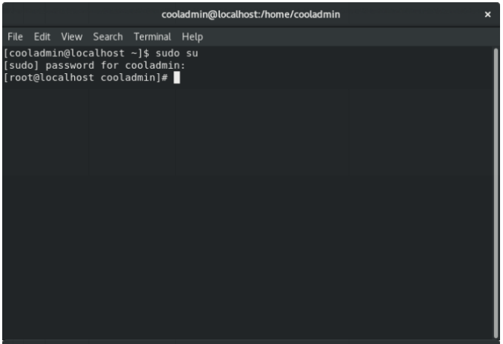

***STEP 2:***

Download the latest version of Xampp

Open up terminal and run the following commands

Download the latest version according to your system.

wget <https://sourceforge.net/projects/xampp/files/latest/download>

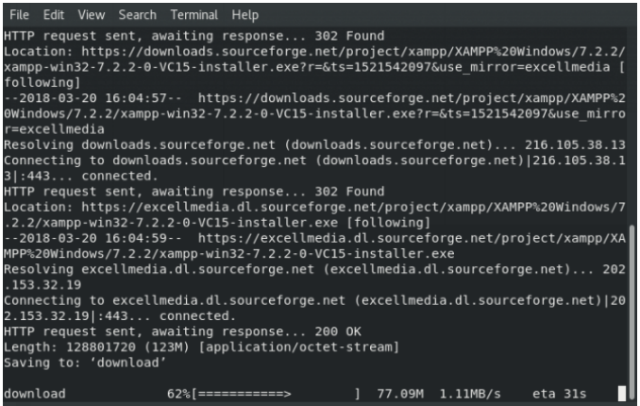

***STEP 3:***

Change the downloaded files permission to an executable and run the file

sudochmod +x xampp-linux-x64-1.8.3-2-installer.run

sudo ./xampp-linux-x64-1.8.3-2-installer.run

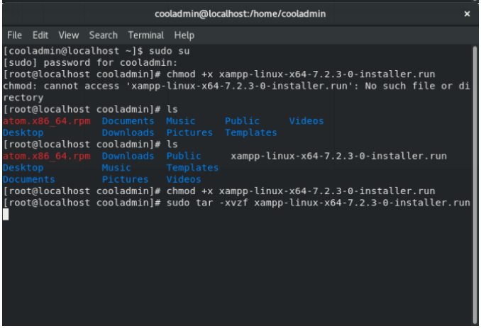

***STEP-4:***

An installation wizard will run. Complete the installation.

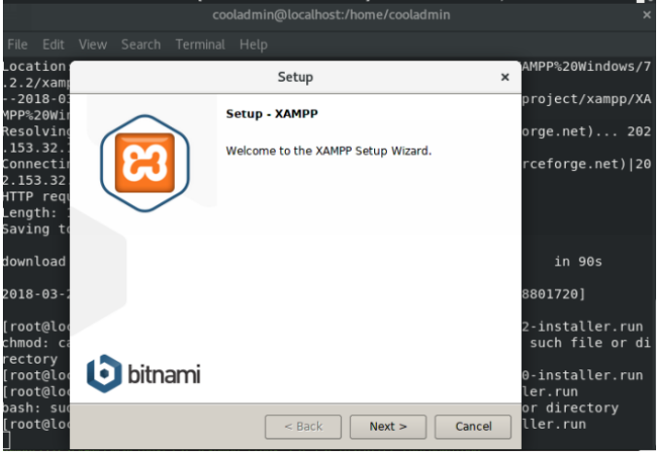

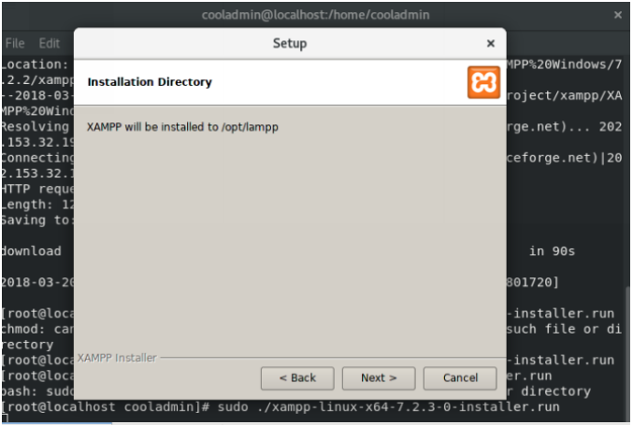

***STEP-5:***

If everything completes without any issue then Xampp Control Panel willrun.



***STEP-6:***

Now visit official website for documentations and further information

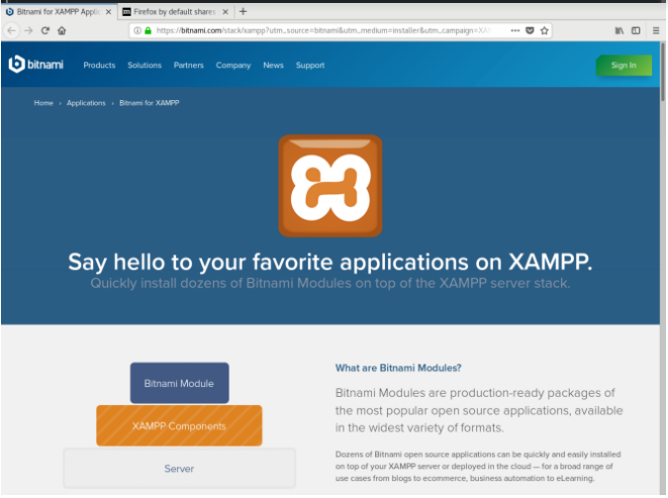

**WEEK-3**

**AIM*:Adding CSS and JavaScript to the static Web-page and Introduction to main, header and footer elements of HTML5.***

**THEORY:**

***3.1: Cascading Style Sheets (CSS)***

Cascading Style Sheets (CSS) is a style sheet language used for describing the presentation of a document written in a markup language. Although most often used to set the visual style of web pages and user interfaces written in HTML and XHTML. Along with HTML and JavaScript.CSS is designed primarily to enable the separation of presentation and content, including aspects such as the layout, colors, and fonts. This separation can improve content accessibility, provide more flexibility and control in the specification of presentation characteristics, enable multiple HTML pages to share formatting by specifying the relevant CSS in a separate .css file, and reduce complexity and repetition in the structural content.

Separation of formatting and content makes it possible to present the same markup page in different styles for different rendering methods, such as on-screen, in print, by voice (via speech-based browser or screen reader), and on Braille-based tactile devices. It can also display the web page differently depending on the screen size or viewing device.

Changes to the graphic design of a document (or hundreds of documents) can be applied quickly and easily, by editing a few lines in the CSS file they use, rather than by changing markup in the documents. The CSS specification describes a priority scheme to determine which style rules apply if more than one rule matches against a particular element. In this so-called cascade, priorities (or weights) are calculated and assigned to rules, so that the results are predictable.

***3.1: JavaScript (JS)***

JavaScript, often abbreviated as JS, is a high-level, dynamic, weakly typed, object-based, multi-paradigm, and interpreted programming language. Alongside HTML and CSS, JavaScript is one of the three core technologies of World Wide Web content production. It is used to make webpages interactive and provide online programs, including video games. The majority of websites employ it, and all modern web browsers support it by built-in JavaScript engine. Each of the many JavaScript is based on the ECMAScript specification, with some engines not supporting the spec fully, and with many engines supporting additional features beyond ECMA.

As a multi-paradigm language, JavaScript supports event-driven, functional, and imperative (including object-oriented and prototype-based) programming styles. It has an API for working with text, arrays, dates, regular expressions, and basic manipulation of the DOM, but does not include any I/O, such as networking, storage, or graphics facilities, relying for these upon the host environment in which it is embedded.

Initially only implemented client-side in web browsers, JavaScript engines are now embedded in many other types of host software, including server-side in web servers and databases, and in non-web programs such as word processors and PDF software, and in runtime environments that make JavaScript available for writing mobile and desktop applications, including desktop widgets.

Although there are strong outward similarities between JavaScript and Java, including language name, syntax, and respective standard libraries, the two languages are distinct and differ greatly in design; JavaScript was influenced by programming languages such as Self and Scheme.

**SOURCE CODE:**

**index.html:**

<!DOCTYPE html>

<html lang="en">

<head>

<meta charset="UTF-8">

<meta name="viewport" content="width=device-width, initial-scale=1.0">

<meta http-equiv="X-UA-Compatible" content="ie=edge">

<title> Lifestyle Store </title>

<link href="style.css" rel="stylesheet" type="text/css"/>

<scriptsrc="js/scripts.js"></script>

</head>

<body>

<div class="topnav" id="myTopnav" style="position: fixed;">

<a href="index.html" class="active" style="padding-right: 50px;">Urban Trap</a>

<a href="products.html">Products</a>

<a href="login.html">Login</a>

<a href="signup.html">Sign Up</a>

<a href="javascript:void(0);" style="font-size:15px;" class="icon" onclick="myFunction()">&#9776;</a>

</div>

<div class="content">

<div class="banner-image">

<div class="inner-banner-image">

<div class="banner_content">

<h1>We sell lifestyle.</h1>

<p style="color: white;">Flat 40% OFF on premium brands</p>

<br><br>

<a href="products.html" class="button">Shop Now</a>

<br><br>

</div>

</div>

</div>

</div>

<div class="container">

<div class="items">

<a href="products.html">

<imgsrc="img/watch.jpg" alt="img" class="thumbnail">

<div class="caption">

<h2>Watches</h2>

<p>Original watches from the best brands.</p>

</div>

</a>

</div>

<div class="items">

<a href="products.html">

<imgsrc="img/camera.jpg" alt="img" class="thumbnail">

<div class="caption">

<h2>Cameras</h2>

<p>Choose among the best available in the world.</p>

</div>

</a>

</div>

<div class="items">

<a href="products.html">

<imgsrc="img/shirt.jpg" alt="img" class="thumbnail">

<div class="caption">

<h2>Shirts</h2>

<p>Our exclusive collection of shirts.</p>

</div>

</a>

</div>

</div>

<footer>

<div>

<center>

<p>

Copyright © Urban Trap. All Rights Reserved <br> Contact Us: <a href="tel:+91 7503604817">+91 7503604817</a><br>Designed & Developed by <a href="mailto:utkarshavardhana85@gmail.com">u8krs</a>

</p>

</center>

</div>

</footer>

</body>

</html>

**style.css:**

body{

width: 100%;

height: 100%;

margin: 0;

font-family: Arial, Helvetica, sans-serif;

}

a{

text-decoration: none;

background-color: transparent;

color:#ededed;

}

.topnav {

overflow: hidden;

width: 100%;

top: 0;

padding: 10px 0px;

z-index: 999;

background-color: rgba(0,0,255,0.5);

}

.topnav a {

float: left;

color: #fff;

display: block;

text-align: center;

padding: 14px 16px;

text-decoration: none;

font-size: 17px;

}

.topnav a:hover{

color: #ff8;

}

.active {

color: white;

}

.topnav .icon {

display: none;

color: #fff;

}

@media screen and (max-width: 600px) {

.topnav a:not(:first-child) {display: none;}

.topnava.icon {

float: right;

display: block;

}

.float-right{

float: right;

}

}

@media screen and (max-width: 600px) {

.topnav.responsive {position: relative;}

.topnav.responsive .icon {

position: absolute;

right: 0;

top: 0;

}

.topnav.responsive a {

float: none;

display: block;

text-align: left;

}

}

.banner-image{

padding-bottom: 30px;

margin-bottom: 15px;

text-align: center;

color: #f8f8f8;

background: url(img/intro-bg_1.jpg) no-repeat center;

background-size: cover;

}

.inner-banner-image{

padding-top: 12%;

width:80%;

margin:auto;

}

.banner_content{

position: relative;

padding-top: 6%;

padding-bottom: 6%;

overflow:hidden;

margin-bottom: 12%;

background-color: rgba(0, 0, 0, 0.7);

min-width: 280px;

}

.button{

color: #fff;

background-color: #c9302c;

border-color: #ac2925;

box-shadow: inset 0 3px 5px rgba(0, 0, 0, .125);

padding: 10px 16px;

font-size: 18px;

border-radius: 6px;

}

.container{

width:90%;

margin:auto;

overflow:hidden;

}

.items{

display: block;

padding: 4px;

margin-bottom: 20px;

line-height: 1.42857143;

background-color: #fff;

border: 1px solid #ddd;

border-radius: 4px;

float:left;

margin-left:1%;

}

@media screen and (max-width: 600px) {

.items{

width:100%;

}

}

@media screen and (min-width: 600px) {

.items{

width:30%;

}

}

.thumbnail{

display: block;

max-width: 100%;

height: auto;

}

.login{

background-color: #f8f8f8;

height: 60vh;

margin: 0% 3% auto;

}

.form-group{

padding: 5px 10px;

}

.form button{

border: 1px solid grey;

padding: 8px 20px;

border-radius: 4px;

background-color: white;

box-shadow: 0px 1px 13px 0px;

}

.form-group input{

border: 1px solid grey;

padding: 8px;

border-radius: 4px;

}

.form-group input:hover{

border: 1px solid blue;

padding: 14px;

font: 16px;

border-radius: 4px;

}

hr{

max-width: 100px;

padding: 2px;

background-color: #352e5a;

border-radius: 4px;

}

.caption{

color:#000;

padding:0px 10px 10px;

font-weight: bold;

text-align: center;

}

.caption h2,p,a{

color:#000;

}

footer{

background-color: #a0949480;

color:#fff;

font-size:14px;

padding: 20px 0px;

}

**script.js:**

functionmyFunction() {

var x = document.getElementById("myTopnav");

if (x.className === "topnav") {

x.className += " responsive";

} else {

x.className = "topnav";

}

}

**SCREEN SHOTS:**

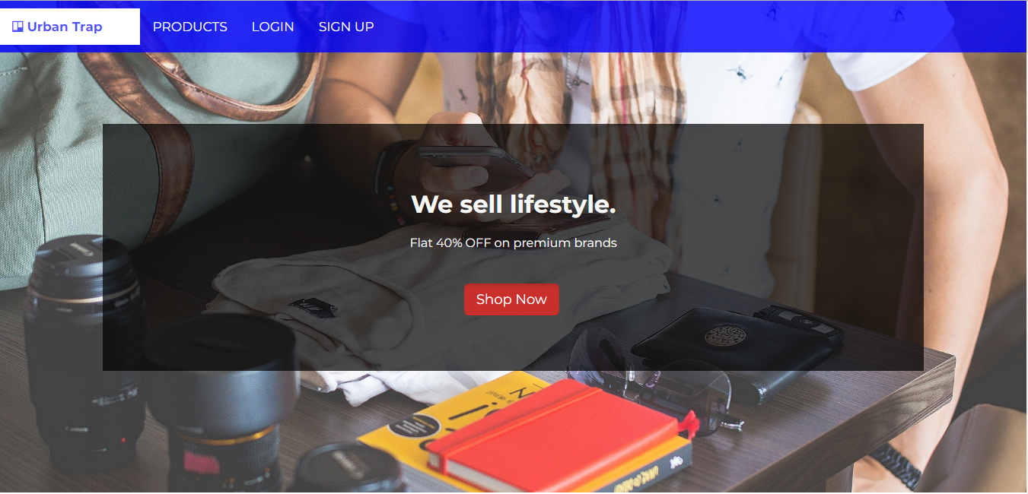

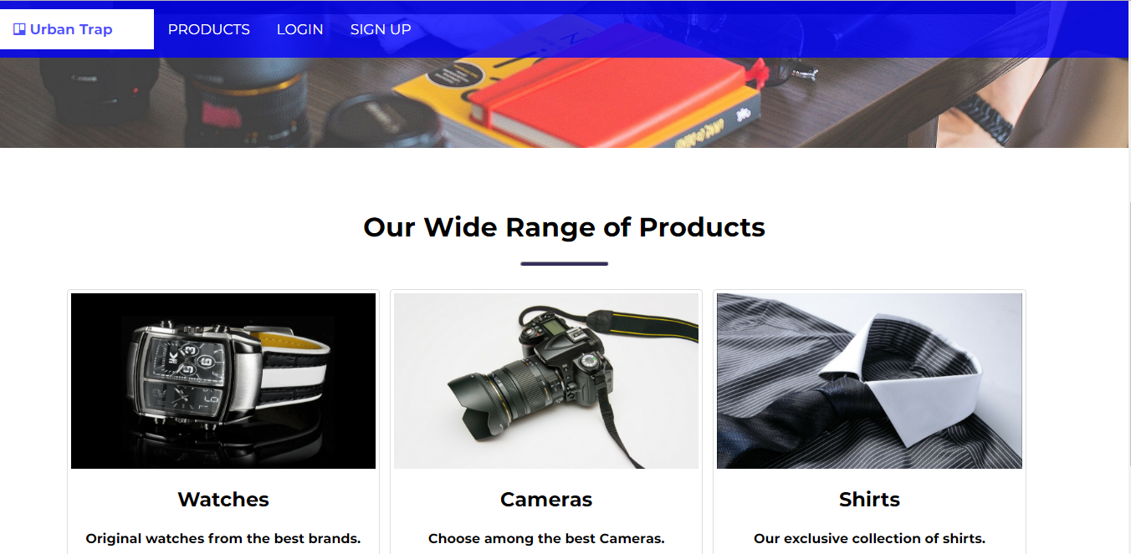

**WEEK-4**

**AIM*:Adding Menus and lists to the Web-page.***

**THEORY:**

***4.1: HTML <menu> tag***

The <menu> tag defines a list/menu of commands.

The <menu> tag is used for context menus, toolbars and for listing form controls and commands.

***4.2: HTML lists***

HTML supports three kinds of lists namely, ordered list, unordered list and definition list.

An unordered list starts with the <ul> tag. Each list item starts with the <li> tag.

The list items will be marked with bullets (small black circles) by default.

An ordered list starts with the <ol> tag. Each list item starts with the <li> tag.

The list items will be marked with numbers by default.

A description list is a list of terms, with a description of each term.

The <dl> tag defines the description list, the <dt> tag defines the term (name), and the <dd> tag describes each term

**SOURCE CODE:**

**products.html:**

<!DOCTYPE html>

<html lang="en">

<head>

<meta charset="UTF-8">

<meta name="viewport" content="width=device-width, initial-scale=1.0">

<meta http-equiv="X-UA-Compatible" content="ie=edge">

<title> Urban Trap | Products </title>

<link href="style.css" rel="stylesheet" type="text/css"/>

<link href="https://fonts.googleapis.com/css?family=Lora:400,400i,700,700i" rel="stylesheet">

<link rel="stylesheet" href="https://cdnjs.cloudflare.com/ajax/libs/font-awesome/4.7.0/css/font-awesome.min.css">

<link href="https://fonts.googleapis.com/css?family=Montserrat:400,700" rel="stylesheet" type="text/css">

<scriptsrc="js/scripts.js"></script>

</head>

<body>

<div class="topnav" id="myTopnav" style="position: fixed;">

<a href="index.html" class="active" style="padding-right: 50px;"><i class="fafa-trello"></i> Urban Trap</a>

<a href="products.html" style="background-color: white; color: rgba(0, 0, 255, 0.7); font-weight: bold;">PRODUCTS</a>

<a href="login.html">LOGIN</a>

<a href="signup.html">SIGN UP</a>

<a href="javascript:void(0);" style="font-size:15px;" class="icon" onclick="myFunction()">&#9776;</a>

</div>

<br><br>

<div class="content">

<div class="container">

<center><h1 style="color: blue;"><br>Our Range of Products</h1></center><hr><br><br>

<div class="items">

<a href="#">

<imgsrc="img/watch.jpg" alt="img" class="thumbnail">

<div class="caption">

<h2>Watches</h2>

<p>Original watches from the best brands.</p>

<a href="products.html" class="button">Buy Now</a>

</div>

</a>

</div>

<div class="items">

<a href="#">

<imgsrc="img/camera.jpg" alt="img" class="thumbnail">

<div class="caption">

<h2>Cameras</h2>

<p>Choose among the best cameras.</p>

<a href="products.html" class="button">Buy Now</a>

</div>

</a>

</div>

<div class="items">

<a href="#">

<imgsrc="img/shirt.jpg" alt="img" class="thumbnail">

<div class="caption">

<h2>Shirts</h2>

<p>Our exclusive collection of shirts.</p>

<a href="products.html" class="button">Buy Now</a>

</div>

</a>

</div>

<div class="items">

<a href="#">

<imgsrc="img/watch.jpg" alt="img" class="thumbnail">

<div class="caption">

<h2>Watches</h2>

<p>Original watches from the best brands.</p>

<a href="products.html" class="button">Buy Now</a>

</div>

</a>

</div>

<div class="items">

<a href="#">

<imgsrc="img/camera.jpg" alt="img" class="thumbnail">

<div class="caption">

<h2>Cameras</h2>

<p>Choose among the best cameras.</p>

<a href="products.html" class="button">Buy Now</a>

</div>

</a>

</div>

<div class="items">

<a href="#">

<imgsrc="img/shirt.jpg" alt="img" class="thumbnail">

<div class="caption">

<h2>Shirts</h2>

<p>Our exclusive collection of shirts.</p>

<a href="products.html" class="button">Buy Now</a>

</div>

</a>

</div>

<div class="items">

<a href="#">

<imgsrc="img/watch.jpg" alt="img" class="thumbnail">

<div class="caption">

<h2>Watches</h2>

<p>Original watches from the best brands.</p>

<a href="products.html" class="button">Buy Now</a>

</div>

</a>

</div>

<div class="items">

<a href="#">

<imgsrc="img/camera.jpg" alt="img" class="thumbnail">

<div class="caption">

<h2>Cameras</h2>

<p>Choose among the best cameras.</p>

<a href="products.html" class="button">Buy Now</a>

</div>

</a>

</div>

<div class="items">

<a href="#">

<imgsrc="img/shirt.jpg" alt="img" class="thumbnail">

<div class="caption">

<h2>Shirts</h2>

<p>Our exclusive collection of shirts.</p>

<a href="products.html" class="button">Buy Now</a>

</div>

</a>

</div>

</div>

</div>

<footer>

<div class="LPartners">

<h3>Our Retail Partners</h3>

<ul style="padding-left: 0;">

<li>BOSS</li>

<li>CASIO</li>

<li>EMONTE</li>

<li>ZARA</li>

<li>NIKON</li>

<li>CANON</li>

</ul>

</div>

<div class="RPartners">

<h3>Our Franchise</h3>

<ul style="padding-left: 0;">

<li>DELHI</li>

<li>CHANDIGARH</li>

<li>TRICHY</li>

<li>LUCKNOW</li>

<li>PATNA</li>

<li>MUMBAI</li>

</ul>

</div>

<hr>

<br>

<div>

<center>

<p>

Copyright © Urban Trap. All Rights Reserved <br><a href="tel:+91 7503604817"><i class="fafa-phone" style="font-size:36px"></i></a><br>Designed & Developed by <a href="mailto:utkarshavardhana85@gmail.com">u8krs</a>

</p>

</center>

</div>

</footer>

</body>

</html>

**SCREEN SHOTS:**

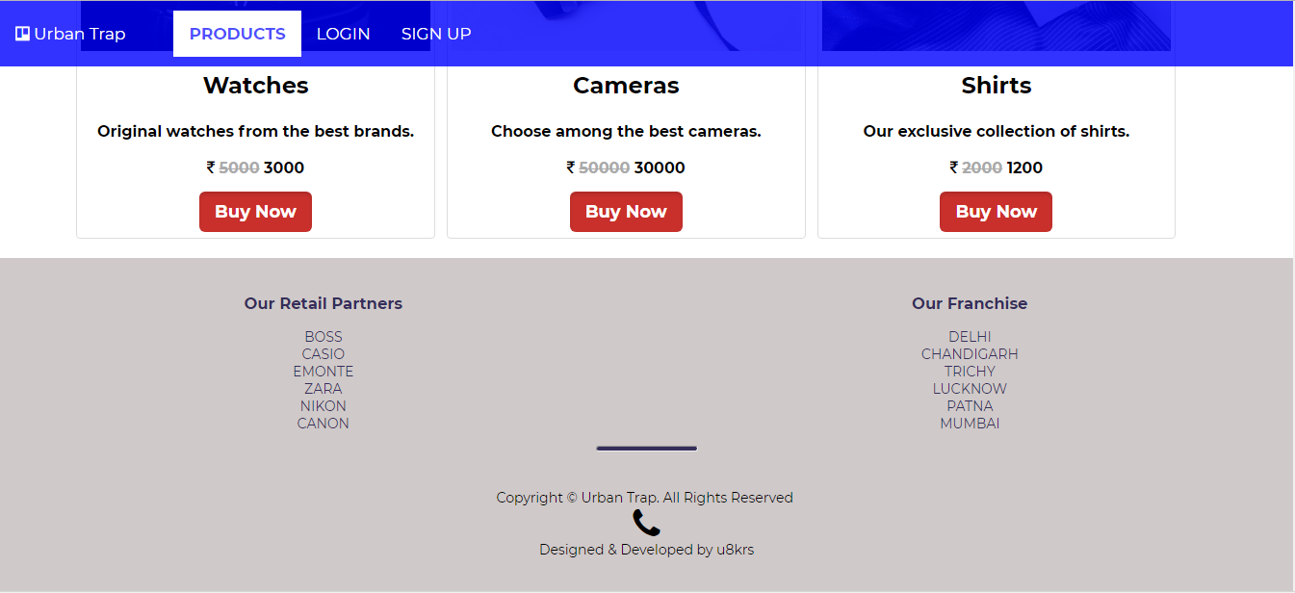

**WEEK-5**

**AIM*:Developing the login and signup forms for the website.***

**THEORY:**

***5.1:The <form> Element***

The HTML <form> element defines a form that is used to collect user input.An HTML form contains form elements.

Form elements are different types of input elements, like text fields, checkboxes, radio buttons, submit buttons, and more.

***5.2:The <input> Element***

The <input> element is the most important form element.

The <input> element can be displayed in several ways, depending on the **type** attribute.

Here are some examples:

|  |  |
| --- | --- |
| **Type** | **Description** |
| <input type="text"> | Defines a one-line text input field |
| <input type="radio"> | Defines a radio button (for selecting one of many choices) |
| <input type="submit"> | Defines a submit button (for submitting the form) |

**SOURCE CODE:**

**login.html:**

<!DOCTYPE html>

<html lang="en">

<head>

<meta charset="UTF-8">

<meta name="viewport" content="width=device-width, initial-scale=1.0">

<meta http-equiv="X-UA-Compatible" content="ie=edge">

<title> Urban Trap | Login </title>

<link href="style.css" rel="stylesheet" type="text/css"/>

<link href="https://fonts.googleapis.com/css?family=Lora:400,400i,700,700i" rel="stylesheet">

<link rel="stylesheet" href="https://cdnjs.cloudflare.com/ajax/libs/font-awesome/4.7.0/css/font-awesome.min.css">

<link href="https://fonts.googleapis.com/css?family=Montserrat:400,700" rel="stylesheet" type="text/css">

<scriptsrc="js/scripts.js"></script>

</head>

<body>

<div class="topnav" id="myTopnav" style="position: fixed;">

<a href="index.html" class="active" style="padding-right: 50px;"><i class="fafa-trello"></i> Urban Trap</a>

<a href="products.html">PRODUCTS</a>

<a href="login.html" style="background-color: white; color: rgba(0, 0, 255, 0.7); font-weight: bold;">LOGIN</a>

<a href="signup.html">SIGN UP</a>

<a href="javascript:void(0);" style="font-size:15px;" class="icon" onclick="myFunction()">&#9776;</a>

</div>

<br><br><br>

<div class="content login">

<center style="vertical-align: center;">

<br>

<b><h1 style="color: blue;">LOGIN</h1></b>

<form class="form" action="index.html" method="post">

<div class="form-group">

<input type="Email" name="email" id="email" class="form-control" placeholder=" Email Id">

</div>

<div class="form-group">

<input type="password" id="password" class="form-control" name="password" placeholder=" Password">

</div>

<br>

<center><button type="submit" class="btnbtn-primary" name="submit">Login</button></center>

</form>

<p>Don't have an account? <a href="signup.html" style="color: blue;">Register</a></p>

</center>

</div>

<footer style="position: absolute; bottom: 0; width: 100%;">

<div>

<center>

<p>

Copyright © Urban Trap. All Rights Reserved <br><a href="tel:+91 7503604817"><i class="fafa-phone" style="font-size:36px"></i></a><br>Designed & Developed by <a href="mailto:utkarshavardhana85@gmail.com">u8krs</a>

</p>

</center>

</div>

</footer>

</body>

</html>

**Signup.html:**

<!DOCTYPE html>

<html lang="en">

<head>

<meta charset="UTF-8">

<meta name="viewport" content="width=device-width, initial-scale=1.0">

<meta http-equiv="X-UA-Compatible" content="ie=edge">

<title> Urban Trap | Sign Up </title>

<link href="style.css" rel="stylesheet" type="text/css"/>

<link href="https://fonts.googleapis.com/css?family=Lora:400,400i,700,700i" rel="stylesheet">

<link rel="stylesheet" href="https://cdnjs.cloudflare.com/ajax/libs/font-awesome/4.7.0/css/font-awesome.min.css">

<link href="https://fonts.googleapis.com/css?family=Montserrat:400,700" rel="stylesheet" type="text/css">

<scriptsrc="js/scripts.js"></script>

</head>

<body>

<div class="topnav" id="myTopnav" style="position: fixed;">

<a href="index.html" class="active" style="padding-right: 50px;"><i class="fafa-trello"></i> Urban Trap</a>

<a href="products.html">PRODUCTS</a>

<a href="login.html">LOGIN</a>

<a href="signup.html" style="background-color: white; color: rgba(0, 0, 255, 0.7); font-weight: bold;">SIGN UP</a>

<a href="javascript:void(0);" style="font-size:15px;" class="icon" onclick="myFunction()">&#9776;</a>

</div>

<br><br><br>

<div class="content login">

<center style="vertical-align: center;">

<br>

<b><h1 style="color: #333;">SIGN UP</h1></b>

<form class="form" action="index.html" method="post">

<div class="form-group">

<input type="text" name="name" id="name" class="form-control" placeholder=" Name">

</div>

<div class="form-group">

<input type="Email" name="email" id="email" class="form-control" placeholder=" Email Id">

</div>

<div class="form-group">

<input type="password" id="password" class="form-control" name="password" placeholder=" Password">

</div>

<div class="form-group">

<input type="text" name="contact" id="contact" class="form-control" placeholder=" Contact">

</div>

<div class="form-group">

<input type="text" name="address" id="address" class="form-control" placeholder=" Address">

</div>

<br>

<center><button type="submit" class="btnbtn-primary" name="submit">Submit</button></center>

</form>

<p>Already have an account? <a href="login.html" style="color: blue;">Login</a></p>

</center>

<br><br>

</div>

<footer>

<div>

<center>

<p>

Copyright © Urban Trap. All Rights Reserved <br><a href="tel:+91 7503604817"><i class="fafa-phone" style="font-size:36px"></i></a><br>Designed & Developed by <a href="mailto:utkarshavardhana85@gmail.com">u8krs</a>

</p>

</center>

</div>

</footer>

</body>

</html>

**SCREEN SHOTS:**

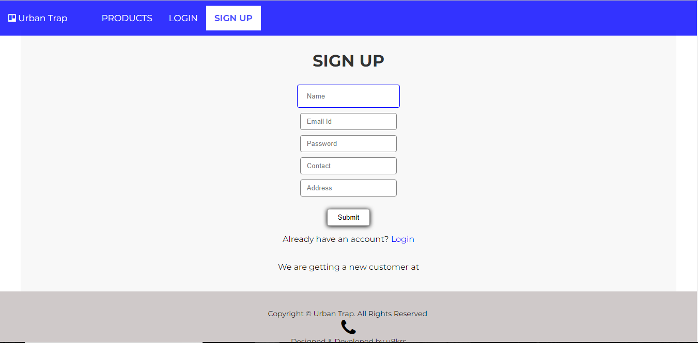

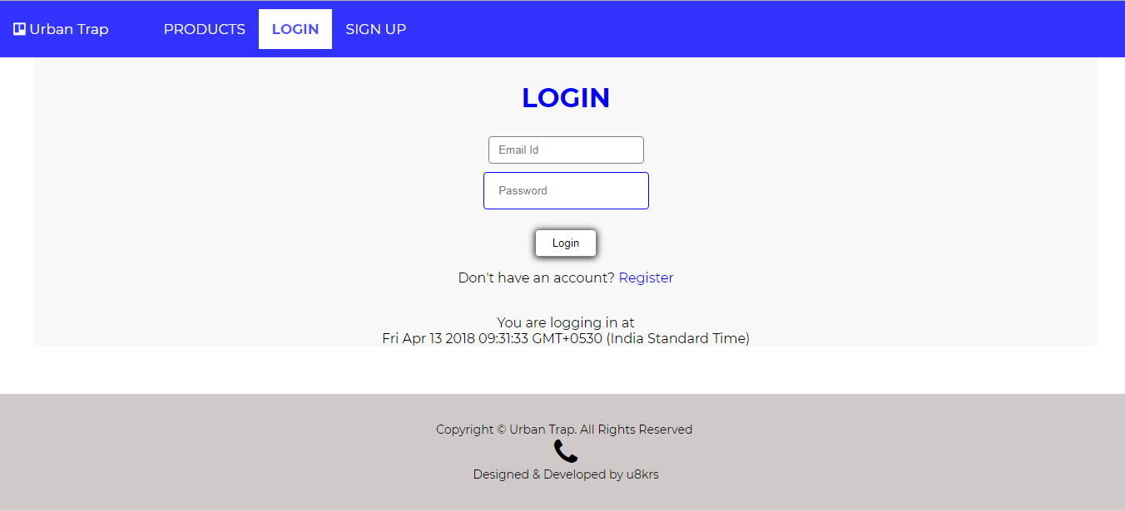

**WEEK-6**

**AIM*:Adding JSP to HTML forms.***

**THEORY:**

***6.1:JAVA Server Pages (JSP)***

JavaServer Pages (JSP) is a technology for developing Webpages that supports dynamic content.

This helps developers insert java code in HTML pages by making use of special JSP tags, most of

which start with <% and end with %>.

A JavaServer Pages component is a type of Java servlet that is designed to fulfill the role of a user

interface for a Java web application. Web developers write JSPs as text files that combine HTML or

XHTML code, XML elements, and embedded JSP actions and commands.

Using JSP, you can collect input from users through Webpage forms, present records from a

database or another source, and create Webpages dynamically.

JSP tags can be used for a variety of purposes, such as retrieving information from a database or

registering user preferences, accessing JavaBeans components, passing control between pages, and

sharing information between requests, pages etc.

***6.2:Why Use JSP?***

JavaServer Pages often serve the same purpose as programs implemented using the Common

Gateway Interface (CGI). But JSP offers several advantages in comparison with the CGI.

• Performance is significantly better because JSP allows embedding Dynamic Elements in

HTML Pages itself instead of having separate CGI files.

• JSP are always compiled before they are processed by the server unlike CGI/Perl which

requires the server to load an interpreter and the target script each time the page is requested.

• JavaServer Pages are built on top of the Java Servlets API, so like Servlets, JSP also has

access to all the powerful Enterprise Java APIs, including JDBC, JNDI, EJB, JAXP, etc.

• JSP pages can be used in combination with servlets that handle the business logic, the model

supported by Java servlet template engines.

**SOURCE CODE:**

**Signup.html:**

<!DOCTYPE html>

<html lang="en">

<head>

<meta charset="UTF-8">

<meta name="viewport" content="width=device-width, initial-scale=1.0">

<meta http-equiv="X-UA-Compatible" content="ie=edge">

<title> Lifestyle Store </title>

<link href="style.css" rel="stylesheet" type="text/css"/>

<scriptsrc="js/scripts.js"></script>

</head>

<body>

<div class="topnav" id="myTopnav" style="position: fixed;">

<a href="index.html" class="active" style="padding-right: 50px;">Urban Trap</a>

<a href="products.html">Products</a>

<a href="login.html">Login</a>

<a href="signup.html">Sign Up</a>

<a href="javascript:void(0);" style="font-size:15px;" class="icon" onclick="myFunction()">&#9776;</a>

</div>

<br><br><br>

<div class="content login">

<center style="vertical-align: center;">

<br>

<b><h1 style="color: blue;">Sign Up</h1></b>

<form id="myForm" class="form" action="conf.jsp" method="post">

<div class="form-group">

<input type="text" name="name" id="name" class="form-control" placeholder=" Name">

</div>

<div class="form-group">

<input type="Email" name="email" id="email" class="form-control" placeholder=" Email Id">

</div>

<div class="form-group">

<input type="password" id="password" class="form-control" name="password" placeholder=" Password">

</div>

<div class="form-group">

<input type="text" name="contact" id="contact" class="form-control" placeholder=" Contact">

</div>

<div class="form-group">

<input type="text" name="address" id="address" class="form-control" placeholder=" Address">

</div>

<center><button type="submit" class="btnbtn-primary" name="submit">Submit</button></center>

</form>

<p>Already have an account? <a href="login.html" style="color: blue;">Login</a></p>

</center>

</div>

<footer style="position: absolute; bottom: 0; width: 100%;">

<div>

<center>

<p>

Copyright © Urban Trap. All Rights Reserved <br> Contact Us: <a href="tel:+91 7503604817">+91 7503604817</a><br>Designed & Developed by <a href="mailto:utkarshavardhana85@gmail.com">u8krs</a>

</p>

</center>

</div>

</footer>

<script>

varstre = document.forms["myForm"]["email"].value;

if (!(stre.match(/^\w+([\.-]?\w+)*@\w+([\.-]?\w+)*(\.\w{2,3})+$/))) {

alert("Invalid email-id");

return false;

}

varstrp = document.getElementById("password").value;

if(strp.length>5){

if (!(strp.match(/(?=.*\d)(?=.*[a-z])(?=.*[A-Z]).{6,}/))) {

alert("Password must contain\none uppercase\none lowercase\none number");

return false;

}

}

else{

alert("password must be atleast 6 character long");

return false;

}

}

</script>

</body>

</html>

**Conf.jsp:**

<!DOCTYPE html>

<%@ page import = "java.io.*,java.util.*" %>

<html>

<head>

</head>

<body>

<h1 style="color:black;text-align:center">CONFIRMATION</h1>

<hr>

<h3>Dear <%out.print(request.getParameter("Name"));%>,</h3>

<p>we are pleased to have you as a part of Urban Trap.</p>

<p>please confirm your details:</br><br>email address : <span style="background:yellow"><%out.print(request.getParameter("email"));%></span><p>

</body>

</html>

**SCREEN SHOTS:**

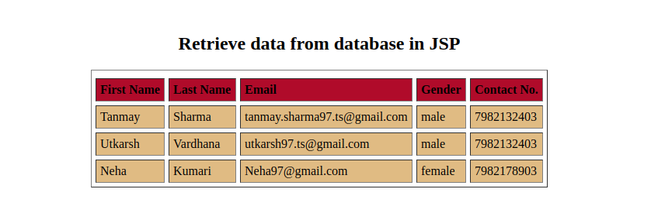

**WEEK-7(a)**

**AIM*:Adding Validations to HTML forms***

**THEORY:**

***7.1:JavaScript Form Validation***

HTML form validation can be done by JavaScript.

If a form field (fname) is empty, this function alerts a message, and returns false, to prevent the form from being submitted.

***7.2:Automatic HTML validations***

HTML form validation can be performed automatically by the browser:

If a form field (fname) is empty, the required attribute prevents this form from being submitted.Automatic HTML form validation does not work in Internet Explorer 9 or earlier.

**SOURCE CODE:**

**Signup.html:**

<!DOCTYPE html>

<html lang="en">

<head>

<meta charset="UTF-8">

<meta name="viewport" content="width=device-width, initial-scale=1.0">

<meta http-equiv="X-UA-Compatible" content="ie=edge">

<title> Lifestyle Store </title>

<link href="style.css" rel="stylesheet" type="text/css"/>

<scriptsrc="js/scripts.js"></script>

</head>

<body>

<div class="topnav" id="myTopnav" style="position: fixed;">

<a href="index.html" class="active" style="padding-right: 50px;">Urban Trap</a>

<a href="products.html">Products</a>

<a href="login.html">Login</a>

<a href="signup.html">Sign Up</a>

<a href="javascript:void(0);" style="font-size:15px;" class="icon" onclick="myFunction()">&#9776;</a>

</div>

<br><br><br>

<div class="content login">

<center style="vertical-align: center;">

<br>

<b><h1 style="color: blue;">Sign Up</h1></b>

<form id="myForm" class="form" action="conf.jsp" method="post">

<div class="form-group">

<input type="text" name="name" id="name" class="form-control" placeholder=" Name">

</div>

<div class="form-group">

<input type="Email" name="email" id="email" class="form-control" placeholder=" Email Id">

</div>

<div class="form-group">

<input type="password" id="password" class="form-control" name="password" placeholder=" Password">

</div>

<div class="form-group">

<input type="text" name="contact" id="contact" class="form-control" placeholder=" Contact">

</div>

<div class="form-group">

<input type="text" name="address" id="address" class="form-control" placeholder=" Address">

</div>

<center><button type="submit" class="btnbtn-primary" name="submit">Submit</button></center>

</form>

<p>Already have an account? <a href="login.html" style="color: blue;">Login</a></p>

</center>

</div>

<footer style="position: absolute; bottom: 0; width: 100%;">

<div>

<center>

<p>

Copyright © Urban Trap. All Rights Reserved <br> Contact Us: <a href="tel:+91 7503604817">+91 7503604817</a><br>Designed & Developed by <a href="mailto:utkarshavardhana85@gmail.com">u8krs</a>

</p>

</center>

</div>

</footer>

<script>

varstre = document.forms["myForm"]["email"].value;

if (!(stre.match(/^\w+([\.-]?\w+)*@\w+([\.-]?\w+)*(\.\w{2,3})+$/))) {

alert("Invalid email-id");

return false;

}

varstrp = document.getElementById("password").value;

if(strp.length>5){

if (!(strp.match(/(?=.*\d)(?=.*[a-z])(?=.*[A-Z]).{6,}/))) {

alert("Password must contain\none uppercase\none lowercase\none number");

return false;

}

}

else{

alert("password must be atleast 6 character long");

return false;

}

}

</script>

</body>

</html>

**SCREEN SHOTS:**

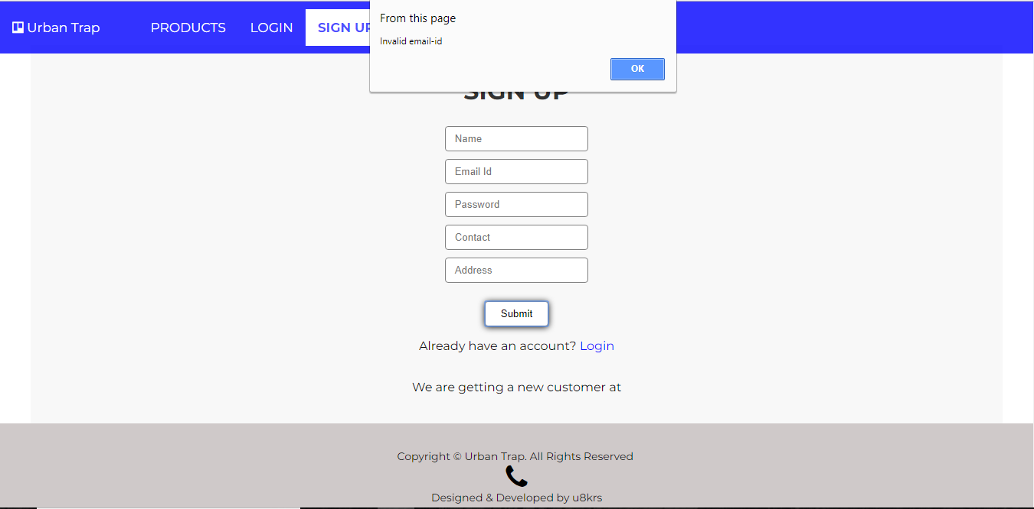

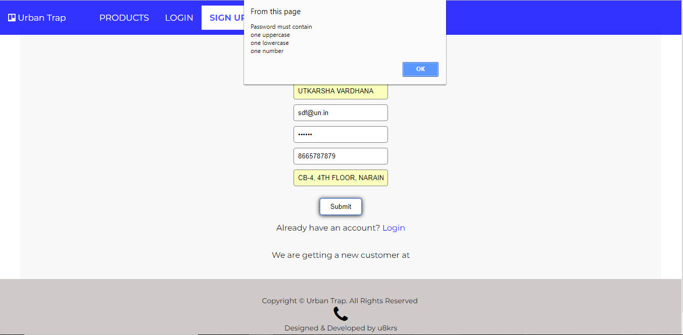

**WEEK-7(b)**

**AIM*:Adding date and time to HTML forms***

**THEORY:**

***7.1:JavaScript Date Formats***

A JavaScript date can be written as a string: Fri Apr 06 2018 00:04:34 GMT+0530 (India Standard Time)

or as a number:1522953274257

Dates written as numbers, specifiy the number of milliseconds since January 1, 1970, 00:00:00.

***7.2:Creating Date Objects***

The Date object lets us work with dates.

A date consists of a year, a month, a day, an hour, a minute, a second, and milliseconds.

Date objects are created with the new Date() constructor.

There are 4 ways of initiating a date:

new Date()

new Date(milliseconds)

new Date(dateString)

new Date(year, month, day, hours, minutes, seconds, milliseconds)

Using new Date(), creates a new date object with the current date and time.

**SOURCE CODE:**

**Signup.html:**

<!DOCTYPE html>

<html lang="en">

<head>

<meta charset="UTF-8">

<meta name="viewport" content="width=device-width, initial-scale=1.0">

<meta http-equiv="X-UA-Compatible" content="ie=edge">

<title> Lifestyle Store </title>

<link href="style.css" rel="stylesheet" type="text/css"/>

<scriptsrc="js/scripts.js"></script>

</head>

<body>

<div class="topnav" id="myTopnav" style="position: fixed;">

<a href="index.html" class="active" style="padding-right: 50px;">Urban Trap</a>

<a href="products.html">Products</a>

<a href="login.html">Login</a>

<a href="signup.html">Sign Up</a>

<a href="javascript:void(0);" style="font-size:15px;" class="icon" onclick="myFunction()">&#9776;</a>

</div>

<br><br><br>

<div class="content login">

<center style="vertical-align: center;">

<br>

<b><h1 style="color: blue;">Sign Up</h1></b>

<form id="myForm" class="form" action="conf.jsp" method="post">

<div class="form-group">

<input type="text" name="name" id="name" class="form-control" placeholder=" Name">

</div>

<div class="form-group">

<input type="Email" name="email" id="email" class="form-control" placeholder=" Email Id">

</div>

<div class="form-group">

<input type="password" id="password" class="form-control" name="password" placeholder=" Password">

</div>

<div class="form-group">

<input type="text" name="contact" id="contact" class="form-control" placeholder=" Contact">

</div>

<div class="form-group">

<input type="text" name="address" id="address" class="form-control" placeholder=" Address">

</div>

<center><button type="submit" class="btnbtn-primary" name="submit">Submit</button></center>

</form>

<p>Already have an account? <a href="login.html" style="color: blue;">Login</a></p>

</center>

</div>

<div class="date" id="date">

</div>

<footer style="position: absolute; bottom: 0; width: 100%;">

<div>

<center>

<p>

Copyright © Urban Trap. All Rights Reserved <br> Contact Us: <a href="tel:+91 7503604817">+91 7503604817</a><br>Designed & Developed by <a href="mailto:utkarshavardhana85@gmail.com">u8krs</a>

</p>

</center>

</div>

</footer>

<script>

varstre = document.forms["myForm"]["email"].value;

if (!(stre.match(/^\w+([\.-]?\w+)*@\w+([\.-]?\w+)*(\.\w{2,3})+$/))) {

alert("Invalid email-id");

return false;

}

varstrp = document.getElementById("password").value;

if(strp.length>5){

if (!(strp.match(/(?=.*\d)(?=.*[a-z])(?=.*[A-Z]).{6,}/))) {

alert("Password must contain\none uppercase\none lowercase\none number");

return false;

}

}

else{

alert("password must be atleast 6 character long");

return false;

}

}

var d = new date;

document.getElementById("date").innerHTML = d.tostring();

</script>

</body>

</html>

**SCREEN SHOTS:**



**WEEK-8**

**AIM*: Adding JavaScript calculations to the HTML page.***

**THEORY:**

***8.1: JavaScript Arithmetic Operators***

Arithmetic operators perform arithmetic on numbers (literals or variables). A typical arithmetic operation operates on two numbers. The two numbers can be literals.

***7.2: Operators and Operands***

The numbers (in an arithmetic operation) are called operands.  
The operation (to be performed between the two operands) is defined by an operator.

***8.2: Operator Precedence***

Operator precedence describes the order in which operations are performed in an arithmetic expression.

e.g.,

var x = 100 + 50 * 3;  
  
As in traditional school mathematics, the multiplication is done first.  
Multiplication (*) and division (/) have higher precedence than addition (+) and subtraction (-).  
And (as in school mathematics) the precedence can be changed by using parentheses.

**SOURCE CODE:**

**Signup.html:**

<!DOCTYPE html>  
<html lang="en">  
<head>  
<meta charset="UTF-8">  
<meta name="viewport" content="width=device-width, initial-scale=1.0">  
<meta http-equiv="X-UA-Compatible" content="ie=edge">  
<title> Urban Trap | Products </title>  
<link href="style.css" rel="stylesheet" type="text/css"/>  
<link href="https://fonts.googleapis.com/css?family=Lora:400,400i,700,700i" rel="stylesheet">  
<link rel="stylesheet" href="https://cdnjs.cloudflare.com/ajax/libs/font-awesome/4.7.0/css/font-awesome.min.css">  
 <link href="https://fonts.googleapis.com/css?family=Montserrat:400,700" rel="stylesheet" type="text/css">  
<script src="js/scripts.js"></script>  
</head>  
<body>  
<div class="topnav" id="myTopnav" style="position: fixed;">  
<a href="index.html" class="active" style="padding-right: 50px;"><i class="fa fa-trello"></i> Urban Trap</a>  
<a href="products.html" style="background-color: white; color: rgba(0, 0, 255, 0.7); font-weight: bold;">PRODUCTS</a>  
<a href="login.html">LOGIN</a>  
<a href="signup.html">SIGN UP</a>  
<a href="javascript:void(0);" style="font-size:15px;" class="icon" onclick="myFunction()">&#9776;</a>  
</div>  
<br><br>  
<div class="content">  
<div class="container">  
<center><h1 style="color: blue;"><br>Our Range of Products</h1></center><hr><br><br>  
<div class="items">  
<a href="#">  
<img src="img/watch.jpg" alt="img" class="thumbnail">  
<div class="caption">  
<h2>Watches</h2>  
<p>Original watches from the best brands.</p>  
<i class="fa fa-inr"></i><strike id="item1" style="color: #aaa">5000</strike><span id="revitem1"></span><br><br>  
<a href="products.html" class="button">Buy Now</a>  
</div>  
</a>  
</div>  
<div class="items">  
<a href="#">  
<img src="img/camera.jpg" alt="img" class="thumbnail">  
<div class="caption">  
<h2>Cameras</h2>  
<p>Choose among the best cameras.</p>  
<i class="fa fa-inr"></i><strike id="item2" style="color: #aaa">50000</strike><span id="revitem2"></span><br><br>  
<a href="products.html" class="button">Buy Now</a>  
</div>  
</a>  
</div>  
<div class="items">  
<a href="#">  
<img src="img/shirt.jpg" alt="img" class="thumbnail">  
<div class="caption">  
<h2>Shirts</h2>  
<p>Our exclusive collection of shirts.</p>  
<i class="fa fa-inr"></i><strike id="item3" style="color: #aaa">2000</strike><span id="revitem3"></span><br><br>  
<a href="products.html" class="button">Buy Now</a>  
</div>  
</a>  
</div>  
<div class="items">  
<a href="#">  
<img src="img/watch.jpg" alt="img" class="thumbnail">  
<div class="caption">  
<h2>Watches</h2>  
<p>Original watches from the best brands.</p>  
<i class="fa fa-inr"></i><strike id="item4" style="color: #aaa">5000</strike><span id="revitem4"></span><br><br>  
<a href="products.html" class="button">Buy Now</a>  
</div>  
</a>  
</div>  
<div class="items">  
<a href="#">  
<img src="img/camera.jpg" alt="img" class="thumbnail">  
<div class="caption">  
<h2>Cameras</h2>  
<p>Choose among the best cameras.</p>  
<i class="fa fa-inr"></i><strike id="item5" style="color: #aaa">50000</strike><span id="revitem5"></span><br><br>  
<a href="products.html" class="button">Buy Now</a>  
</div>  
</a>  
</div>  
<div class="items">  
<a href="#">  
<img src="img/shirt.jpg" alt="img" class="thumbnail">  
<div class="caption">  
<h2>Shirts</h2>  
<p>Our exclusive collection of shirts.</p>  
<i class="fa fa-inr"></i><strike id="item6" style="color: #aaa">2000</strike><span id="revitem6"></span><br><br>  
<a href="products.html" class="button">Buy Now</a>  
</div>  
</a>  
</div>  
<div class="items">  
<a href="#">  
<img src="img/watch.jpg" alt="img" class="thumbnail">  
<div class="caption">  
<h2>Watches</h2>  
<p>Original watches from the best brands.</p>  
<i class="fa fa-inr"></i><strike id="item7" style="color: #aaa">5000</strike><span id="revitem7"></span><br><br>  
<a href="products.html" class="button">Buy Now</a>  
</div>  
</a>  
</div>  
<div class="items">  
<a href="#">  
<img src="img/camera.jpg" alt="img" class="thumbnail">  
<div class="caption">  
<h2>Cameras</h2>  
<p>Choose among the best cameras.</p>  
<i class="fa fa-inr"></i><strike id="item8" style="color: #aaa">50000</strike><span id="revitem8"></span><br><br>  
<a href="products.html" class="button">Buy Now</a>  
</div>  
</a>  
</div>  
<div class="items">  
<a href="#">  
<img src="img/shirt.jpg" alt="img" class="thumbnail">  
<div class="caption">  
<h2>Shirts</h2>  
<p>Our exclusive collection of shirts.</p>  
<i class="fa fa-inr"></i><strike id="item9" style="color: #aaa">2000</strike><span id="revitem9"></span><br><br>  
<a href="products.html" class="button">Buy Now</a>  
</div>  
</a>  
</div>  
<div class="items">  
<a href="#">  
<img src="img/watch.jpg" alt="img" class="thumbnail">  
<div class="caption">  
<h2>Watches</h2>  
<p>Original watches from the best brands.</p>  
<i class="fa fa-inr"></i><strike id="item10" style="color: #aaa">5000</strike><span id="revitem10"></span><br><br>  
<a href="products.html" class="button">Buy Now</a>  
</div>  
</a>  
</div>  
<div class="items">  
<a href="#">  
<img src="img/camera.jpg" alt="img" class="thumbnail">  
<div class="caption">  
<h2>Cameras</h2>  
<p>Choose among the best cameras.</p>  
<i class="fa fa-inr"></i><strike id="item11" style="color: #aaa">50000</strike><span id="revitem11"></span><br><br>  
<a href="products.html" class="button">Buy Now</a>  
</div>  
</a>  
</div>  
<div class="items">  
<a href="#">  
<img src="img/shirt.jpg" alt="img" class="thumbnail">  
<div class="caption">  
<h2>Shirts</h2>  
<p>Our exclusive collection of shirts.</p>  
<i class="fa fa-inr"></i><strike id="item12" style="color: #aaa">2000</strike><span id="revitem12"></span><br><br>  
<a href="products.html" class="button">Buy Now</a>  
</div>  
</a>  
</div>  
  
</div>  
</div>  
<footer>  
<div class="LPartners">  
<h3>Our Retail Partners</h3>  
<ul style="padding-left: 0;">  
<li>BOSS</li>  
<li>CASIO</li>  
<li>EMONTE</li>  
<li>ZARA</li>  
<li>NIKON</li>  
<li>CANON</li>  
</ul>  
</div>  
<div class="RPartners">  
<h3>Our Franchise</h3>  
<ul style="padding-left: 0;">  
<li>DELHI</li>  
<li>CHANDIGARH</li>  
<li>TRICHY</li>  
<li>LUCKNOW</li>  
<li>PATNA</li>  
<li>MUMBAI</li>  
</ul>  
</div>  
<hr>  
<br>  
<div>  
<center>  
<p>  
 Copyright © Urban Trap. All Rights Reserved <br><a href="tel:+91 7503604817"><i class="fa fa-phone" style="font-size:36px"></i></a><br>Designed & Developed by <a href="mailto:utkarshavardhana85@gmail.com">u8krs</a>  
</p>  
</center>  
</div>  
</footer>  
<script>  
 document.getElementById("revitem1").innerHTML=5000*6/10;  
 document.getElementById("revitem2").innerHTML=50000*6/10;  
 document.getElementById("revitem3").innerHTML=2000*6/10;  
 document.getElementById("revitem4").innerHTML=5000*6/10;  
 document.getElementById("revitem5").innerHTML=50000*6/10;  
 document.getElementById("revitem6").innerHTML=2000*6/10;  
 document.getElementById("revitem7").innerHTML=5000*6/10;  
 document.getElementById("revitem8").innerHTML=50000*6/10;  
 document.getElementById("revitem9").innerHTML=2000*6/10;  
 document.getElementById("revitem10").innerHTML=5000*6/10;  
 document.getElementById("revitem11").innerHTML=50000*6/10;  
 document.getElementById("revitem12").innerHTML=2000*6/10;  
</script>  
</body>  
</html>

**SCREEN SHOTS:**

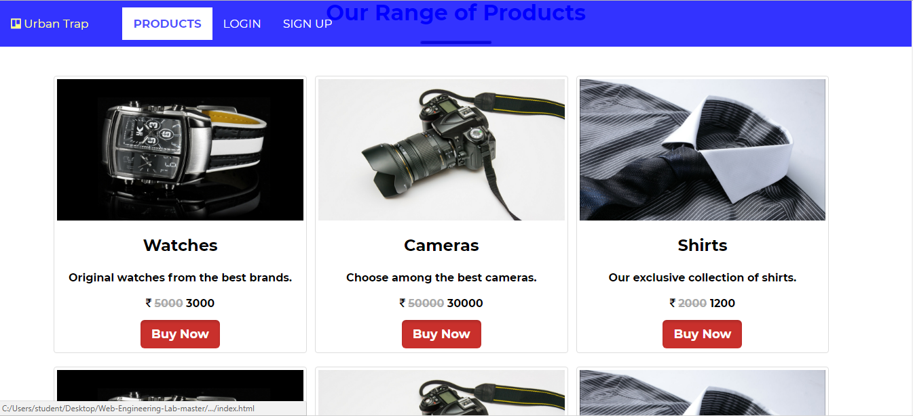

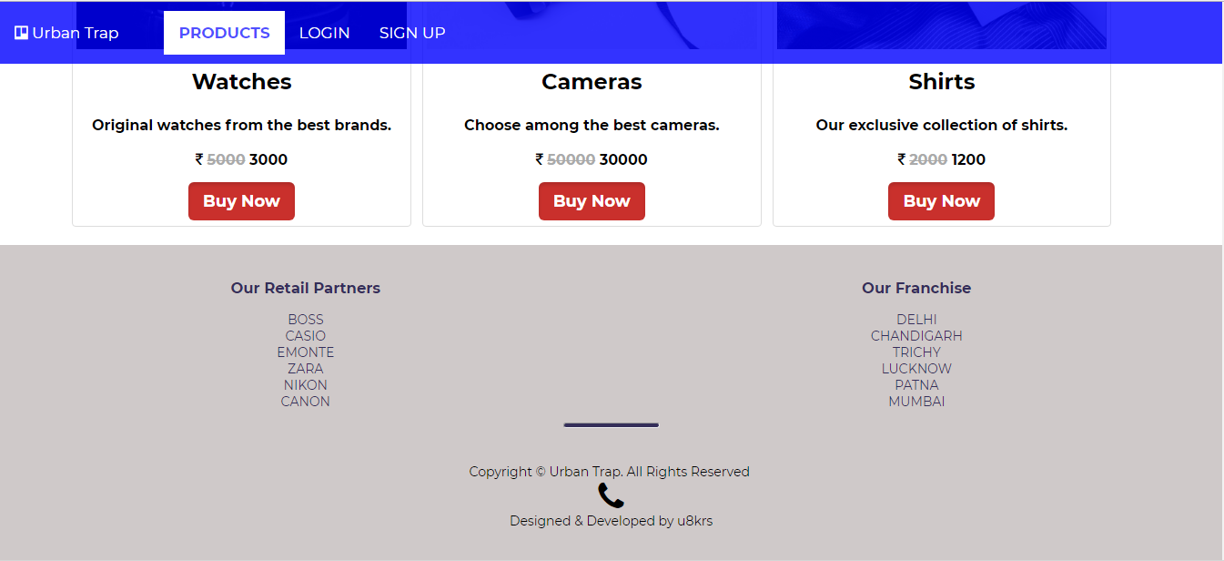

**WEEK-9**

**AIM*: Adding XLS and XSLT to the HTML page.***

**THEORY:**

***9.1: Displaying XML with XSLT***

XSLT (eXtensible Stylesheet Language Transformations) is the recommended style sheet language for XML.

XSLT is far more sophisticated than CSS. With XSLT you can add/remove elements and attributes to or from the output file. You can also rearrange and sort elements, perform tests and make decisions about which elements to hide and display, and a lot more.

XSLT uses XPath to find information in an XML document.

**SOURCE CODE:**

**Index.xls:**

<?xml version="1.0" encoding="UTF-8"?>

<?xml-stylesheet type="text/xsl" href="index.xsl"?>

<breakfast_menu>

<food>

<name>Camera</name>

<price>$5.95</price>

<description>Nikon</description>

</food>

<food>

<name>Watch</name>

<price>$7.95</price>

<description>Casio</description>

</food>

<food>

<name>Shirts</name>

<price>$8.95</price>

<description>Van Heusen</description>>

</food>

<food>

<name>Camera</name>

<price>$5.95</price>

<description>Nikon</description>

</food>

<food>

<name>Watch</name>

<price>$7.95</price>

<description>Casio</description>

</food>

<food>

<name>Shirts</name>

<price>$8.95</price>

<description>Van Heusen</description>>

</food>

</breakfast_menu>

**Index.xlst:**

<?xml version="1.0" encoding="UTF-8"?>

<html xsl:version="1.0" xmlns:xsl="http://www.w3.org/1999/XSL/Transform">

<body style="font-family:Arial;font-size:12pt;background-color:#EEEEEE">

<xsl:for-each select="breakfast_menu/food">

<div style="background-color:green;color:white;padding:20px">

<span style="font-weight:bold"><xsl:value-of select="name"/> - </span>

<xsl:value-of select="price"/>

</div>

<div style="margin-left:20px;margin-bottom:1em;font-size:10pt">

<p>

<xsl:value-of select="description"/>

<span style="font-style:italic"> (<xsl:value-of select="calories"/> price per item)</span>

</p>

</div>

</xsl:for-each>

</body>

</html>

**SCREEN SHOTS:**

